TOPIC 6 - VECTORS
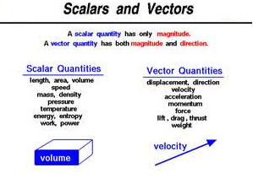
Two Dimension Vectors  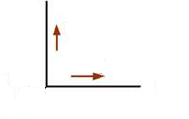 | Three Dimension Vectors  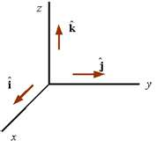
Example of a 3-D vector
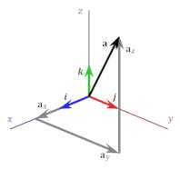

Magnitude(modulus) and Direction of a vector
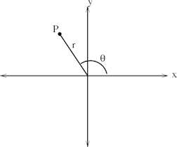 | Let P(x, y)  $$r=\left|\vec{OP}\right|=\sqrt{x^{2}+y^{2}}$$  $θ$= the direction of $\vec{OP}$.  For 3-Dimension  Let $\underline{a }=x\underline{i }+y\underline{j }+z\underline{k}$  $$r=\left|\underline{a}\right|=\sqrt{x^{2}+y^{2}+z^{2}}$$

- Two vectors, A and B are equal if they have the same magnitude and direction, regardless of whether they have the same initial points.
. 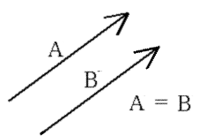
- A vector having the same magnitude as A but in the opposite direction to A is denoted by -A.
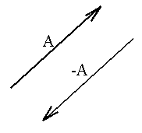
Position Vector and Displacement Vector
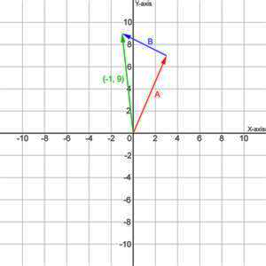$\vec{OA }=position vector, vector B is a displacement vector.$

Scalar Multiplication of a Vector
- $\underline{b}=k\underline{a}$ and k > 0 $\underline{b}$ and $\underline{a}$ are in the same direction and $\left|\underline{b}\right|=k\left|\underline{a}\right|$.
- $\underline{b}=k\underline{a}$ and k < 0 $\underline{ b}$ and $\underline{a}$ are in the same direction and $\left|\underline{b}\right|=k\left|\underline{a}\right|$.
Addition of Vectors
- Triangle Law of Addition
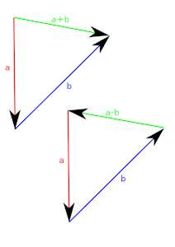
- Parallelogram Law
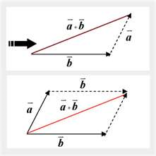
Example 1

Example 2

Example 3
Example 4
Example 5

Unit Vector
A vector with a magnitude of 1, $\left|\underline{a}\right|=1.$
$\hat{a}$ = $\frac{\underline{a}}{\underline{\left|a\right|}}$
Example 6

Scalar Product
There are two ways of ‘multiplying’ vectors:
- Scalar product (dot product) – gives a scalar result.
- Vector product (cross product) – the product gives a vector result.
The dot product(scalar product) of vectors $\underline{a}$ and $\underline{b}$ is defined as
$\underline{a }∙\underline{b}=\left|\underline{a}\right|\left|\underline{b}\right|\cos{θ}$ where $θ$ is the angle between two vectors.

Example 7

Example 8
Example 9
Example 10
Example 11

Note:

